Computer Programming Using Python 2.7 - **Unit4 Panda3d with NetBeans - Part 0: Intro to NetBeans**

To work at home, install python 2.7, Panda3D SDK for Developers 1.7.2, then install NetBeans 7.3 with JDK (Java Developer’s Kit) which is at <http://www.oracle.com/technetwork/java/javase/downloads/jdk-netbeans-jsp-142931.html>

Click the download beside where it says Windows x86 version.

NetBeans needs the Developer Plugins setting to use python.

* Open NetBeans
* Click “Tools”, “Plugins”
* Click the “Settings” tab, then click “Add”. For name type “Developer Updates”. For URL, copy & paste:
* <http://deadlock.netbeans.org/hudson/job/nbms-and-javadoc/lastStableBuild/artifact/nbbuild/nbms/updates.xml.gz>

then click OK (Emory)

* Wait for it to download. When it is finished you can click “Available Plugins” tab, then click Name to sort by Name (or type Python in search box) then check Python, then click Install, Next, Accept, Install.
* After it is finished, make sure Restart IDE Now is selected, then click Finish.
* After it finishes restarting, click Tools, Python Platforms
* By default, Jython is selected. Instead, click *Python* on left.
* Click “Make Default”
* In the Main tab, for Console Command click Browse.
* Click Computer, C:, Panda3D-1.7.2, python folder, then choose ppython (not python)

*C:\Panda3D-1.7.2\python\ppython.exe*

*Then copy and paste to Command:*

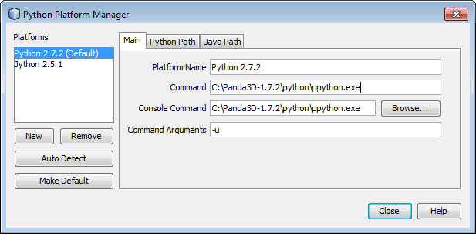

* Click Python Path tab. Remove all lines except NetBeans (no longer need any python lines such as C:\Python27\lib\site-packages\wx-2.8-msw-unicode etc).
* Add each of these by clicking Add then pasting each:

*C:\Panda3D-1.7.2\python\python.exe*

*C:\Panda3D-1.7.2\python\DLLs*

*C:\Panda3D-1.7.2\python\Lib*

*C:\Panda3D-1.7.2\python\Lib\lib-tk*

*C:\Panda3D-1.7.2\python\python26.zip*

*C:\Panda3D-1.7.2\python\lib\plat-win*

*C:\Panda3D-1.7.2\python*

*C:\Panda3D-1.7.2*

*C:\Panda3D-1.7.2\bin*

*C:\Panda3D-1.7.2\python\lib\site-packages*

* Click Close

(Lang 13-14)

Works Cited

<<https://techknowhow.library.emory.edu/blogs/sturnbu/2011/05/12/netbeans-7-and-python-ide>> Apr 15, 2014